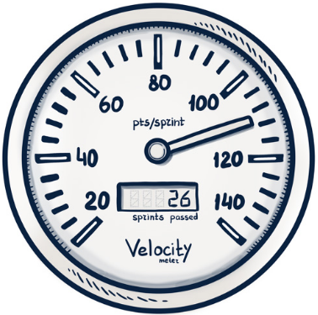

Demo Date: 10/16/2019

Group Number: 2

Member Names:

Grant Culver

Paul Whitely

James Cox

Project Title: Automobile Inventory Management

GitHub URL: <https://github.com/gculver/SoftwareEngineering_FinalProject>

Demo URL: <https://rocky-ocean-99188.herokuapp.com/users/login>

**Project Feature List**

* Consolidate Ordering into One Platform – No longer switching between screens or spreadsheets trying to figure out what to order.
* Measure Inventory Effectiveness Vs. Industry Standards – Measure you inventory effectiveness to become more profitable.
* Realtime Inventory Tracking – No longer looking 30 days back. Can look real time what your inventory position is.
* Login Authentication and management.

**System Requirement**

* Internet Connection
* User Access

